**Assignment – 5 (LIMIT, IS NULL, IS NOT NULL, LIKE, NOT LIKE, AS aliases and ORDER BY)**

1. Write SQL command to perform the following:
2. Create a table called my_class(pk_roll_no, first_name, last_name, address, marks(out of 500),age (division(according to marks like first, second, distinction, third, pass, fail)

**Constraints applied:**

* + You must give first name
  + Age must be greater than 17.
  + Division should be given as fail if not provided by the user.

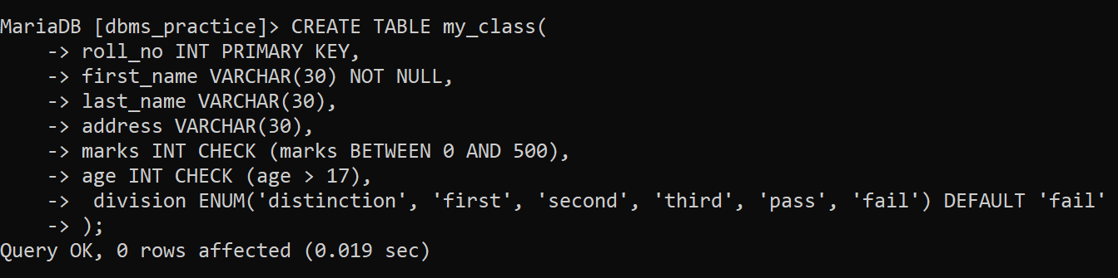

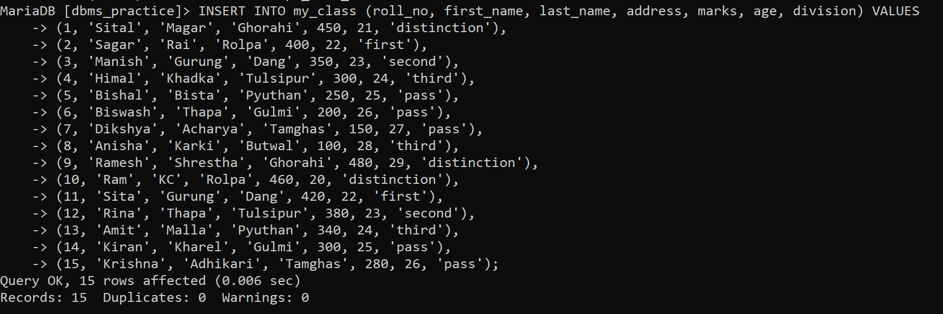

1. Select the first five classmates. (LIMIT)

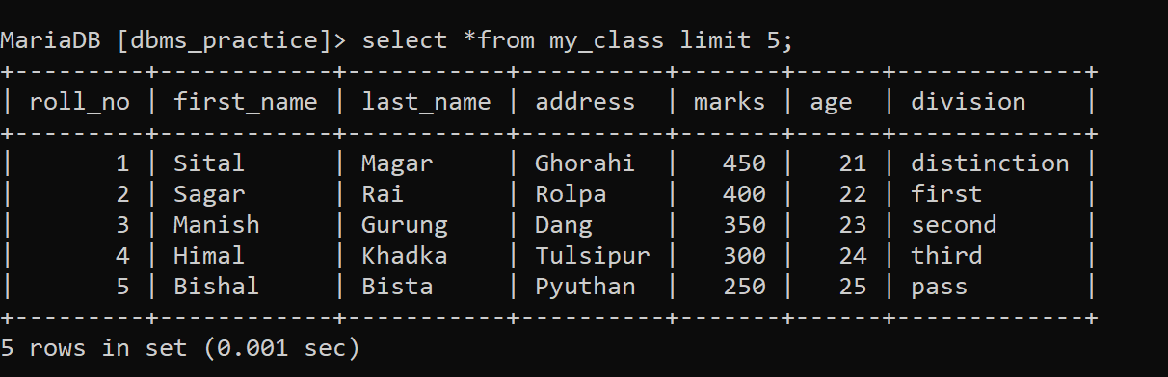

1. Select the classmates whose first name starts with ‘R’.

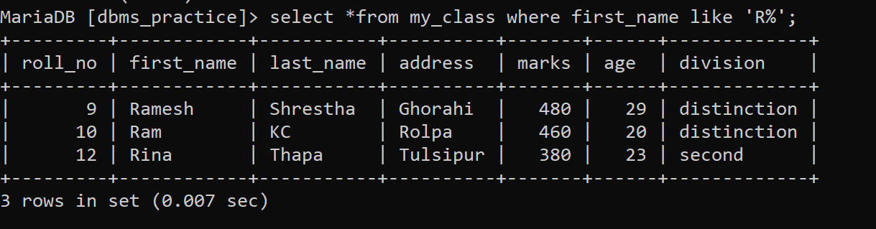

1. Select the classmates whose first name contains ‘a’ in their name.

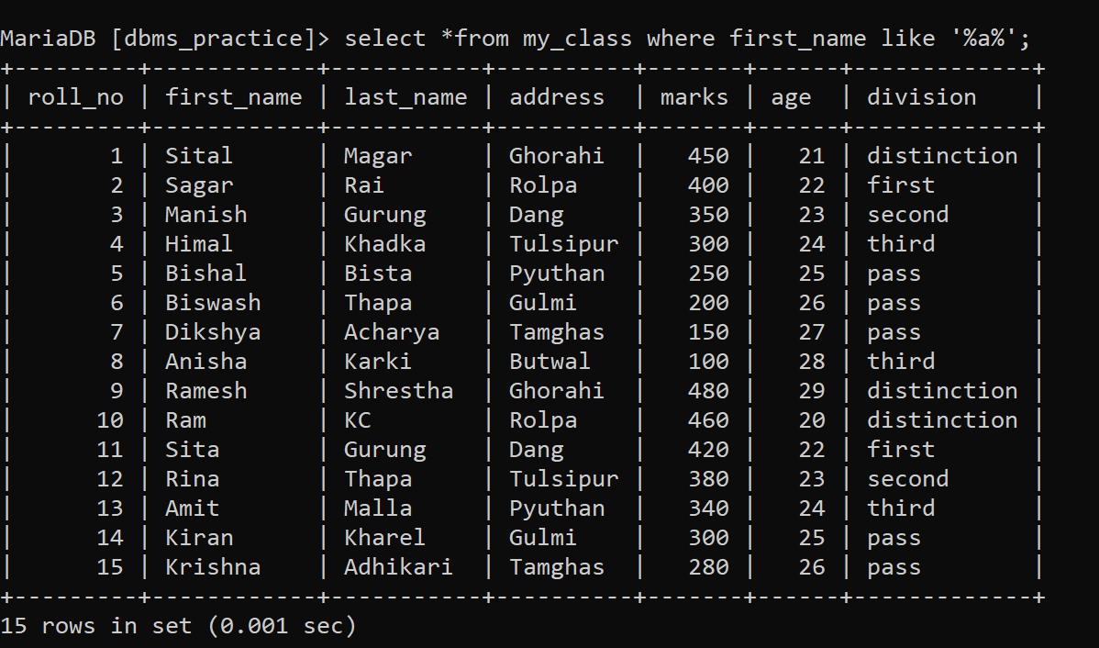

1. Select the classmates whose last name contains ‘s’ as the second last character.



1. Select the classmates whose last name is not known yet. (IS NULL)



1. Select all the classmates who address is known. (IS NOT NULL)

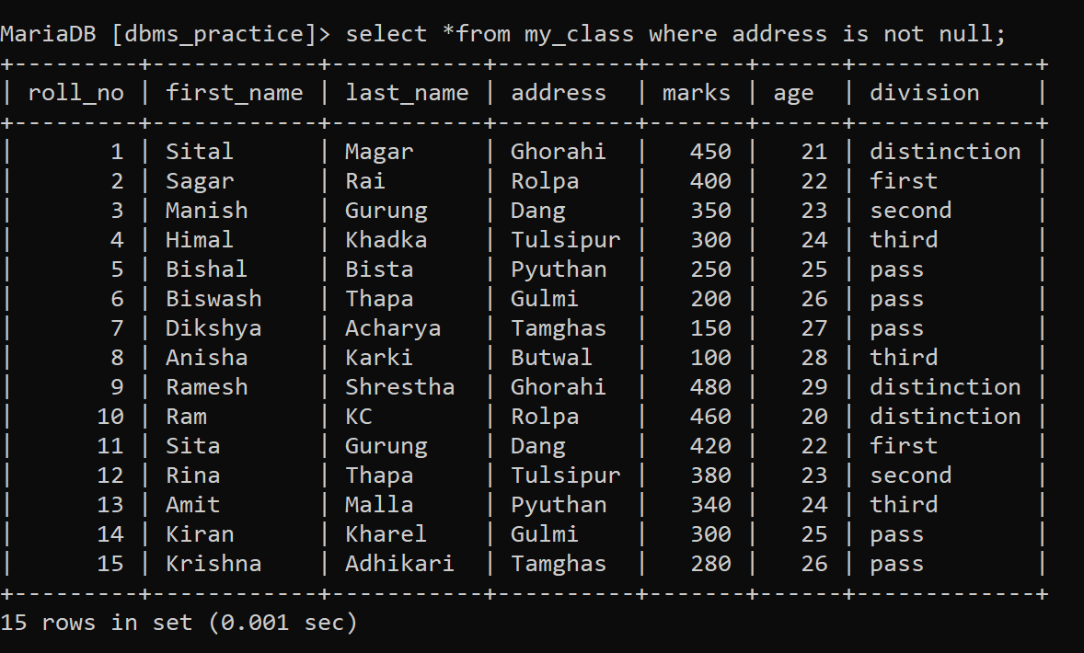

1. Select the students whose age is between 20 and 30 and lives in ‘Ghorahi’, ‘Rolpa’,’Dang’ ,’Tulsipur’.

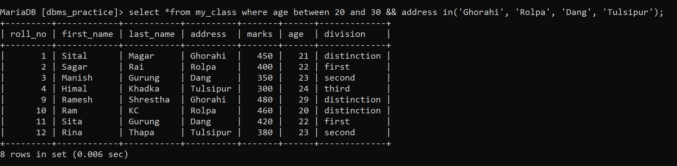

1. Select all the students whose name does not end with ‘a’.

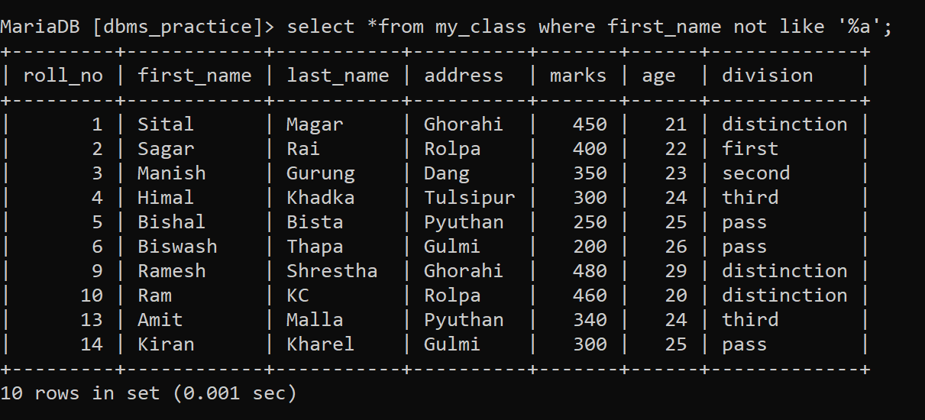

1. Select all the students whose name starts with ‘a’ but does not end with ‘a’.

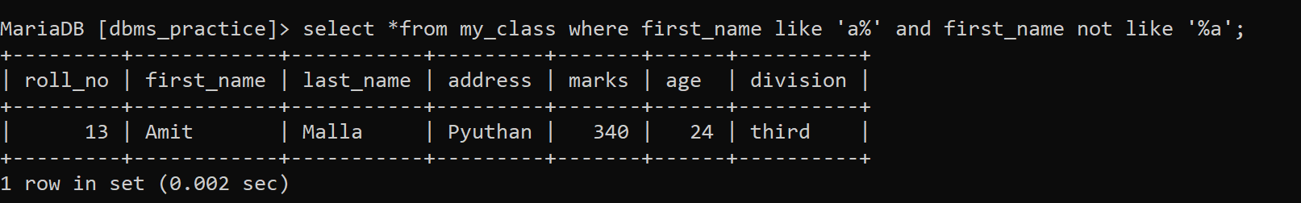

1. Select the classmates and sort them in ascending order by their name.

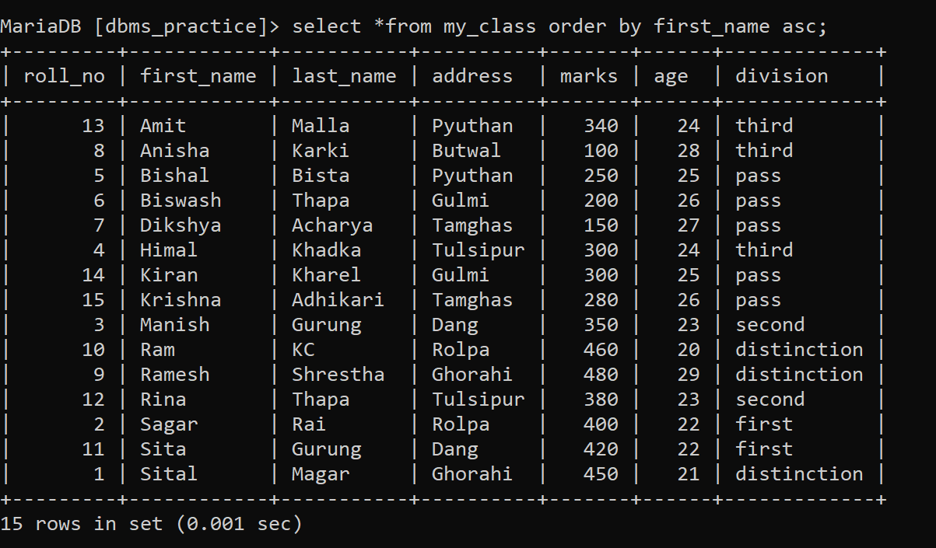

1. Select the classmates and sort them as highest scorer to lowest scorer.

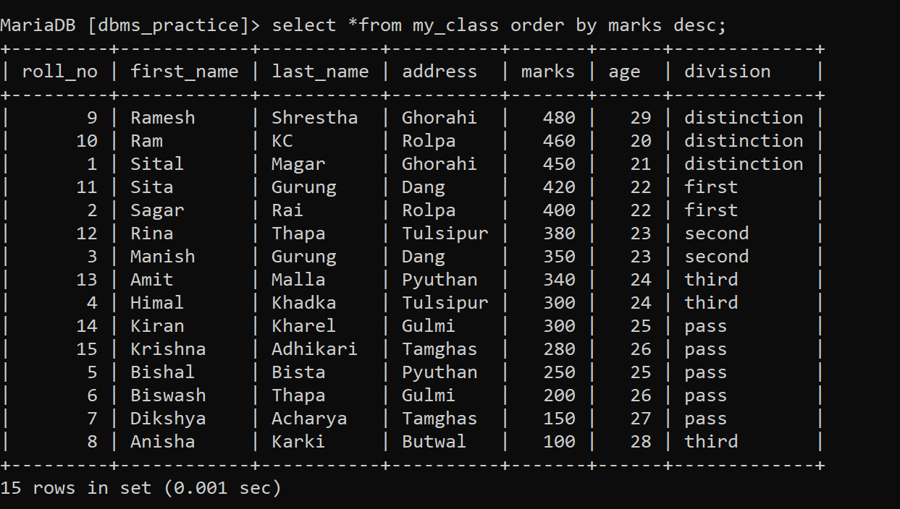

1. Select the classmates who have exactly five characters in their first name.

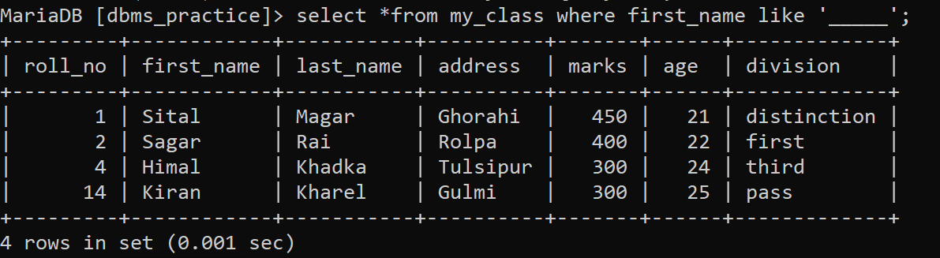

1. Select all the classmates who has scored the marks in two digits only.



1. Teacher wants to know if they increase each of the students marks by 5, how much their marks will reach to. Write SQL query which will select student id, name, marks and new marks which will contains the improved marks.

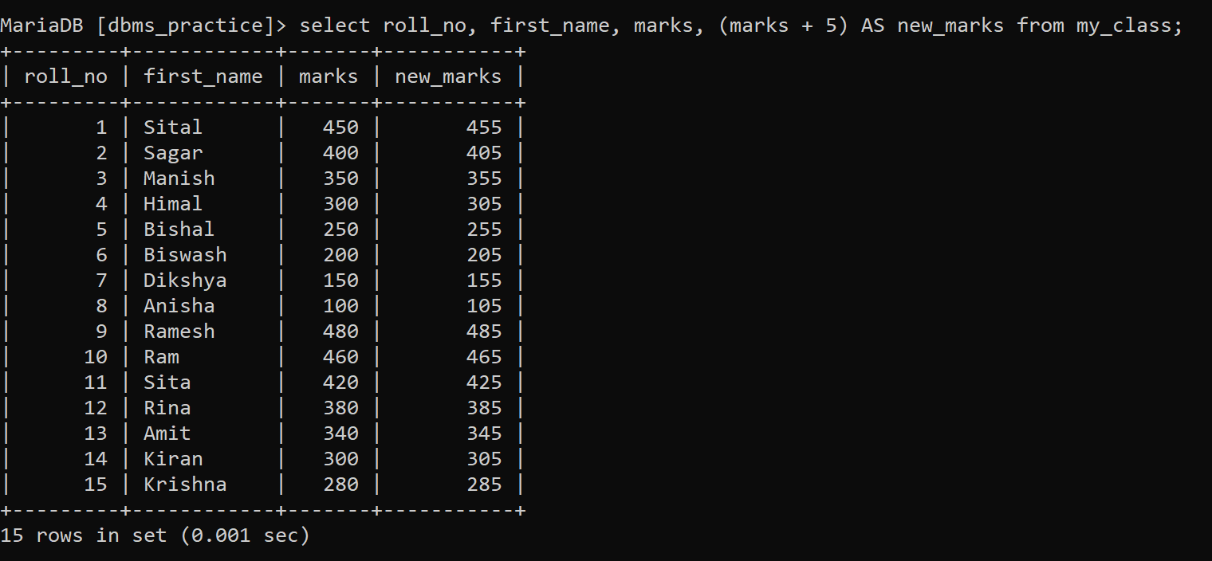

1. College administration wants to know the different locations students come from (Note: They don't want to see the duplicate locations).

